**Name: Ali Hassaan Mughal**

**BSCS 6B**

**CMS No: 173627**

**Task 1:**

**Part 1:**

**Code:**

**from PIL import Image**

**import os, sys**

**"""**

**Opening and showing image.**

**"""**

**im = Image.open("task1.png")**

**print(im.format,im.size,im.mode)**

**im.show()**

**im.close()**

**Output:**



**Part 2:**

**Code:**

**from PIL import Image**

**import os, sys**

**"""**

**Converting and Writing Image to .jpg**

**"""**

**for infile in sys.argv[1:]:**

**f, e = os.path.splitext(infile)**

**print(infile)**

**outfile = f + ".jpg"**

**if infile != outfile:**

**try:**

**Image.open(infile).save(outfile)**

**except IOError:**

**print("cannot convert", infile)**

**Output:**



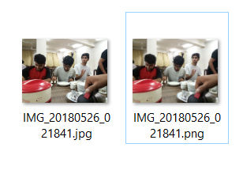

**Task 2: I have read out the tutorial on Numpy and understand the functions like np.array() np.sort() and other functions like transpose etc.**

**Task 3:**

**Part 1**

**Code:**

from PIL import Image

img = Image.open('task31.jpg').convert('LA')

img.save('task31greyscale.png')

**Output:**

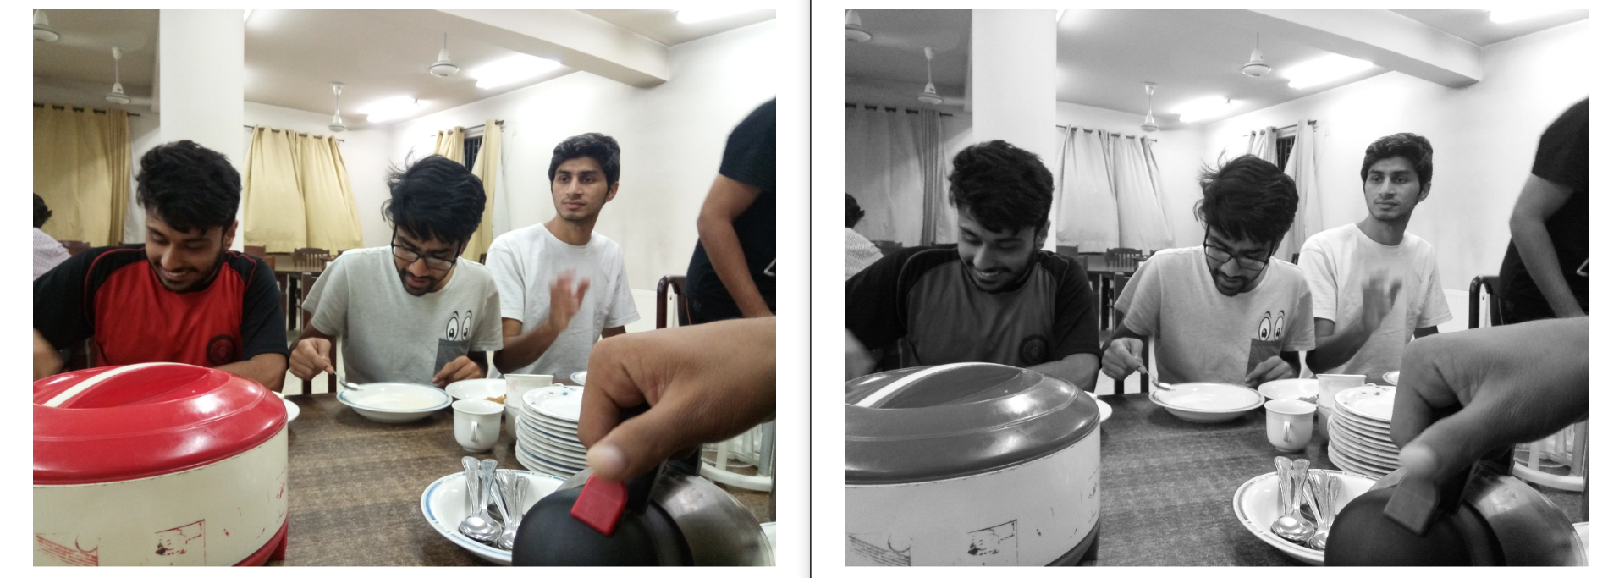

**Part 2**

**Code:**

from PIL import Image,ImageFilter

img = Image.open('task32.jpg')

smoothenedimage = img.filter(ImageFilter.SMOOTH_MORE)

smoothenedimage.save("task32smoothened.jpg")

**Output:**

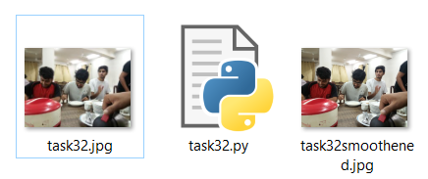

**Part 3**

**Code:**

**from PIL import Image,ImageFilter**

**img = Image.open('task33.jpg')**

**smoothenedimage = img.filter(ImageFilter.SHARPEN)**

**smoothenedimage.save("task33sharpen.jpg")**

**Output:**

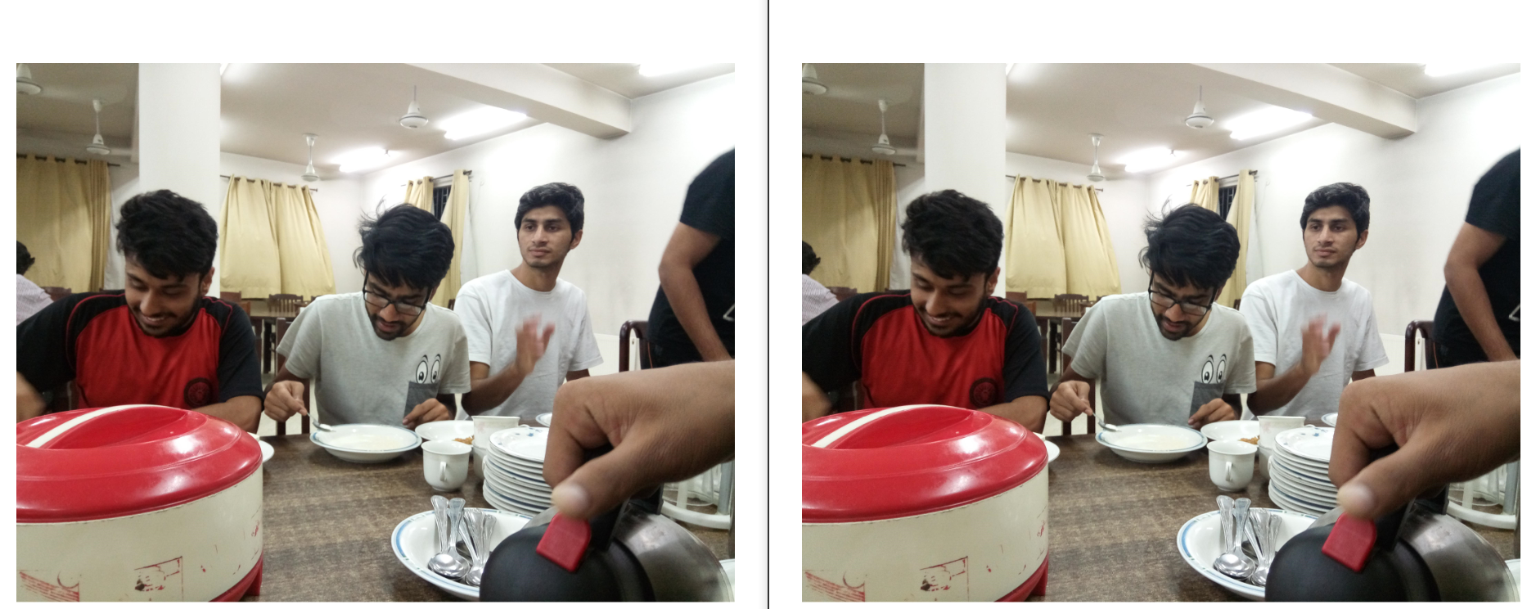

**Part 4**

**Code:**

**import sys**

**import numpy as np**

**import matplotlib.pyplot**

**import matplotlib.image**

**file = "task34.jpg"**

**img = matplotlib.image.imread(file)**

**gray_img = np.dot(img[...,:3], [0.299, 0.587, 0.114])**

**matplotlib.pyplot.imshow(gray_img, cmap = matplotlib.pyplot.get_cmap('gray'))**

**matplotlib.pyplot.show()**

**outFileName = file.split('.')[0] + "_grayscale(manual).jpg"**

**matplotlib.pyplot.imsave(outFileName, gray_img, cmap="gray")**

**print("Grayscale")**

**print("Image", file, "Converted to", outFileName)**

**Output:**

